**MOBILE COMPUTING**

SHWETA. P. PATIL

Department of Information Science & Engg

BLDEA’s VP Dr. P. G. Halakatti College of Engg& Technology,

Bijapur-586103

State: Karnataka

Country: India

Email Id: [shwetapatil93@live.com](mailto:shwetapatil93@live.com)

SOUMYA. R. HALAKATTI

Department of Computer Science & Engg

BLDEA’s VP Dr. P. G. Halakatti College of Engg& Technology,

Bijapur-586103

State: Karnataka

Country: India

Email Id: soumyahalakatti92@gmail.com

POOJA. D. JOSHI

Department of Computer Science & Engg

BLDEA’s VP Dr. P. G. Halakatti College of Engg& Technology,

Bijapur-586103

State: Karnataka

Country: India

Email Id: poojadjoshi92@gmail.com

***Abstract*: A technology that allows transmission of data, via a computer, without having to be connected to a fixed physical link is so called Mobile Computing. Mobile Computing is a booming technology. It is one of the rapidly evolving technologies as it allows users to transmit data from one remote location to other remote or fixed locations.**

**Mobile computing is a form of human–computer interaction i.e. a user would be able to browse the web, check e-mail, play digital music, and perform all other computing activities without having to be behind a desktop at home or work. An extension of this technology is the ability to send and receive data across these cellular networks. This is the principle of mobile computing.**

**Mobile computing has three aspects: mobile communication, mobile hardware and mobile software. The first aspect addresses communication issues in ad-hoc and infrastructure networks. The second aspect is on the hardware. The third aspect deals with the characteristics and requirements of mobile applications. Portability is a another important aspect of mobile computing.**

**Mobile Computing has a variety of wireless devices that has the mobility to allow people to connect to the internet, providing wireless transmission to access data and information**

**Mobile computing affects entire spectrum of issues in computing. So two major problems that arise due to mobility are**

**1. Searching for current location of a mobile node.**

**2. To impose a communication structure among nodes.**

***KEYWORDS: Portable Computing Device, Wireless Network Infrastructure, Application Software Suite.***

### I. INTRODUCTION

Mobile Computing can be defined as a technology that allows computation and transmission of data, via computing devices, without having to be connected to a physical data transmission link.

The computing device typically has a display screen and an input/output mechanism for human-device interaction.

Mobile computing aims to provide a network infrastructure and corresponding terminal (display) capability to perform all desktop-like computing functions seamlessly at any place or time, even while the terminal is moving. This means that anytime and anywhere, a user would be able to browse the web, check e-mail, play digital music, and perform all other computing activities without having to be behind a desktop at home or work. At its best, mobile computing would allow a user to have access to a consistent working environment.

**II. BUILDING BLOCKS OF MOBILE COMPUTING**

The basic building blocks of Mobile Computing are

* Portable computing device
* Wireless network infrastructure
* Application Software Suite

**1. PORTABLE COMPUTING DEVICE**

Portable computing device is a general-purpose computer that can be easily moved from place to place. It has an display screen and I/o mechanism for human computer interaction. Apart from an OS, it has an advanced computing ability and network connectivity feature.

There are several categories of portable computing devices that can run on batteries and with varying degree of processing speed such as portable computers, keyboard less tablet PCs, Internet tablets, PDAs, ultra mobile PCs (UMPCs) and Smartphone.

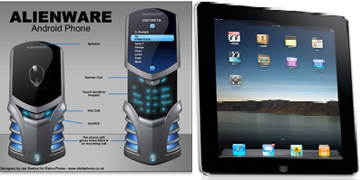

Figure 1: Computing Devices

**2. WIRELESS N/W INFRASTRUCTURE**

Wireless connectivity for handheld computers also comes in several varieties. Most handheld computers come with built-in infrared ports that can be used to exchange information with a network or another computer at short range. Many of them can connect to wireless local area networks (LANs) based on the IEEE 802.11 standard. Some cellular telephone service providers are also making cell phone modules available for attachment to the expansion slots of handheld computers. Bluetooth, a new wireless standard for personal area networking, is also available for some handheld computers. Wireless technologies, includes 802.11b, otherwise known as Wi-Fi, Infrared Data Association (IrDA), Ultra-Wideband Radio (UWB), and Home RF are being applied to similar technologies that Bluetooth use with mixed results. 802.11 is the most well-known technology, excluding Bluetooth, and uses the same radio frequency, meaning that they are not compatible as they cause interference with each other. 802.11 is being implemented into universities in the US, Japan and China, as well as food and beverage shops where they are being used to identify students and customers. Even airports have taken up the 802.11 technology, with airports allover America, and three of America’s most prominent airlines promoting the use of it. Infrared Data Association is extremely inferior to that of Bluetooth. Its limitations include only being able to communicate point-to-point, needing a line of sight, and it has a speed of fifty- six kilobytes per second, whereas Bluetooth is one megabyte per second. The Ultra- Wideband Radio is superior to that of Bluetooth in that it can transmit at greater lengths (up to 70 meters), with only half of the power that Bluetooth uses. HomeRF is a technology that is not very well known. It is used for data and voice communication and targeted for the residential market segment and does not serve enterprise- class WLANs, public access systems or fixed wireless Internet access.

The figure shows the Wireless Network Infrastructure.

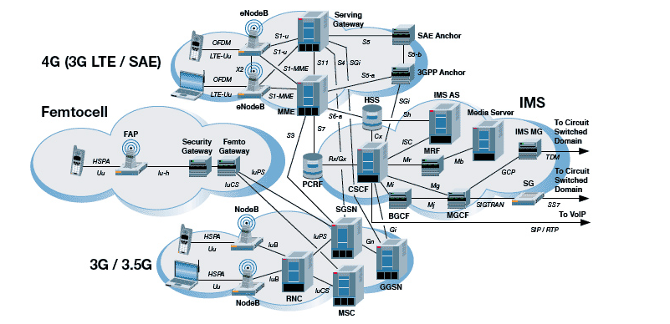

**Figure 2: Wireless Network Infrastructure**

**3. APPLICATION SOFTWARE SUITE**

A host of application software which specializes in business use cases such as railway ticket booking, streaming an video from an website such as YouTube.

Much of the advances in mobile computing are currently focused on business applications. The technology available and being developed is designed to increase productivity, efficiency and connectivity for workers in a range of fields from retail to professional. The advent of wireless networking has created new opportunities in the design of instructional space. Computing systems are currently present in many forms of customer service; mobile computing has the potential to have applications for a greater range of these businesses. Traveling sales representatives have the potential to offer consumers a demonstration of their product, simply through the use of a PDA(Personal Digital Assistants),wireless laptop, or other mobile device.

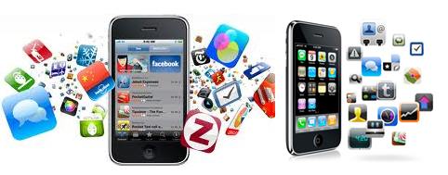

Figure 3: Illustration of several application softwares.

**III. BENEFITS**

## There are 3 Key Benefits from the business perspective. They are-

## Improved Decision Making: Mobile Computing lets you conduct business at the point of activity. The ability to collect, access and evaluate critical business information quickly and accurately means better decision making that can have a far-reaching effect on your company's ability to compete successfully.

## Increased productivity and reduced costs: Mobile computing can lead to increased individual productivity, increased sales per sales person, more service calls per repair person, less time spent by professionals on administrative work, and much more--all of which ultimately translates into higher sales at lower cost. And, on-the-spot invoice production in service vehicles can lead to shorter payment cycles and better cash flow.

## Improved customer relations: The success of a business can often be measured by its ability to satisfy customers. Mobile computers gives your field worker the ability to answer customer questions, check order status and provide other services anytime their customers need them from wherever they happen to be.

**IV. CONSTRAINTS**

Mobile computing is characterized by 6constraints

* Insufficient bandwidth:

Mobile Internet access is generally slower than direct cable connections, using technologies such as [GPRS](http://en.wikipedia.org/wiki/GPRS) and [EDGE](http://en.wikipedia.org/wiki/EDGE), and more recently [HSDPA](http://en.wikipedia.org/wiki/HSDPA) and [HSUPA](http://en.wikipedia.org/wiki/HSUPA)[3G](http://en.wikipedia.org/wiki/3G) networks. These networks are usually available within range of commercial cell phone towers. Higher speed [wireless LANs](http://en.wikipedia.org/wiki/Wireless_LAN) are inexpensive but have very limited range.

* **Security standards**:

When working mobile, one is dependent on public networks, requiring careful use of [VPN](http://en.wikipedia.org/wiki/Virtual_private_networks). Security is a major concern while concerning the mobile computing standards on the fleet. One can easily attack the VPN through a huge number of networks interconnected through the line.

* **Power consumption**:

When a power outlet or portable generator is not available, mobile computers must rely entirely on battery power. Combined with the compact size of many mobile devices, this often means unusually expensive batteries must be used to obtain the necessary battery life.

* **Transmission interferences**:

Weather, terrain, and the range from the nearest signal point can all interfere with signal reception. Reception in tunnels, some buildings, and rural areas is often poor.

* **Potential health hazards**:

People who use mobile devices while driving are often distracted from driving and are thus assumed more likely to be involved in traffic accidents.[[3]](http://en.wikipedia.org/wiki/Mobile_computing#cite_note-2) (While this may seem obvious, there is considerable discussion about whether banning mobile device use while driving reduces accidents or not.[[4]](http://en.wikipedia.org/wiki/Mobile_computing#cite_note-3)[[5]](http://en.wikipedia.org/wiki/Mobile_computing#cite_note-4)) Cell phones may interfere with sensitive medical devices. There are allegations that cell phone signals may cause health problems.

* **Human interface with device**:

Screens and keyboards tend to be small, which may make them hard to use. Alternate input methods such as speech or handwriting recognition require training.

**V. CONCLUSION**

Mobile computers offer many new options; however there are difficulties to consider. Generally, wireless laptops cost 50% to 100% more than their desktop counterparts. Laptops are also harder to upgrade most proprietary hardware components that limit future options.

The cost of setup for mobile computing varies depending on the number of employees, and the hardware required. The initial investment in this technology remains risky, as the market is rapidly changing and improving.

REFERENCES

* <http://www.wikipedia.org>
* <http://www.newimagesoftware.net>
* <http://www.faadooengineers.com>
* <http://techfinder.fiercewireless.com>